Vmobile Contractor Engagement Policy and Procedures Guide

Contents

Purpose & Scope 2

Applicability 2

Policy Administration 2

Contractor Categories 3

Contractor Types at Vmobile 3

Engagement and Oversight 4

Performance Evaluation 5

Security and Compliance 5

Summary Table: Contractor Types and Primary Responsibilities 5

Engagement Rules 5

Contractor Engagement Rules 6

Onboarding & Offboarding Process 7

Contractor Onboarding Procedure 7

Performance & Compliance Monitoring 8

Supervisor Feedback 8

Project Milestones 9

Contractor Engagement Overview 9

Contractor Type Comparison 10

Engagement Procedures 10

Contractor Management Responsibilities 10

Contractor Distribution by Department 11

Departmental Engagement Guidelines 11

# Purpose & Scope

Vmobile maintains a dedicated contractor engagement policy to ensure the consistent, compliant, and effective management of non-employee personnel supporting our critical telecom operations. This policy is designed to safeguard Vmobile’s assets, maintain operational integrity, and uphold our commitment to regulatory compliance. All contractors engaged in technical, operational, and customer-facing roles across Vmobile’s US business units are subject to the provisions outlined herein.

Contractors play a vital role in Vmobile’s service delivery, network maintenance, and customer support functions. Therefore, it is essential that their engagement is governed by clear, standardized procedures that align with Vmobile’s corporate values and legal obligations. This policy establishes the expectations, responsibilities, and requirements for contractors, as well as the processes by which Vmobile manages contractor relationships.

## Applicability

This policy applies to:

* All contractors working on Vmobile premises, remotely, or at client sites under Vmobile direction.
* Contractors engaged through third-party agencies, direct contracts, or managed service providers.
* Roles including, but not limited to, network engineering, field operations, IT systems administration, customer service, project management, and technical support.

## Policy Administration

The Vmobile Human Resources (HR) and Information Technology (IT) departments jointly administer this policy. HR is responsible for contractor onboarding, documentation, and compliance, while IT manages access provisioning, security controls, and technical support for contractor personnel.

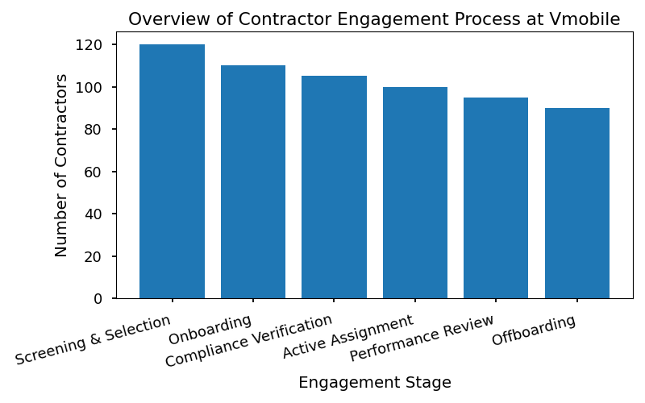

# Contractor Categories

Vmobile engages a diverse range of contractors to support our dynamic operations and ensure the highest standards of service delivery. Each contractor category fulfills specific roles essential to our business continuity, technological advancement, and customer satisfaction. The following contractor types are officially recognized within Vmobile, and all employees and managers must adhere to the associated policies and procedures for engagement, supervision, and performance evaluation.

## Contractor Types at Vmobile

* **Field Technicians**

Field Technicians are responsible for installing, maintaining, and repairing Vmobile’s mobile network infrastructure. Their duties include servicing cell sites, troubleshooting connectivity issues, and performing on-site repairs at customer locations. Field Technicians play a critical role in ensuring network availability and reliability.

* **IT Support Specialists**

IT Support Specialists provide technical support for Vmobile’s internal systems, including network equipment, software platforms, and user hardware. They respond to helpdesk tickets, resolve technical incidents, and assist with system upgrades and troubleshooting. Their expertise ensures smooth operation of all technological assets across the organization.

* **Customer Care Trainers**

Customer Care Trainers design and deliver comprehensive training programs for Vmobile’s customer service representatives. Their focus is on telecom products, service procedures, and system usage. Trainers ensure that all customer-facing staff are equipped with up-to-date knowledge to deliver exceptional service.

* **Network Optimization Analysts**

Network Optimization Analysts analyze network performance data, identify areas for improvement, and recommend actionable solutions to enhance coverage and reliability. Their work directly impacts customer experience and operational efficiency by driving continuous improvement of Vmobile’s network infrastructure.

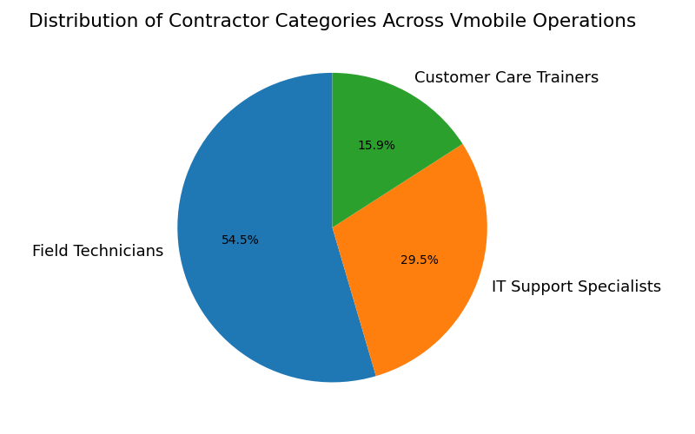

## Engagement and Oversight

All contractor engagements at Vmobile must comply with the official Contractor Management Policy, including background verification, onboarding procedures, and adherence to Vmobile’s Code of Conduct. Supervisors are responsible for monitoring contractor performance and ensuring alignment with Vmobile’s strategic objectives.

## Performance Evaluation

Contractors are subject to regular performance reviews, conducted by department managers in coordination with HR. Evaluation criteria include technical proficiency, adherence to safety standards, communication effectiveness, and contribution to project goals. Contractors failing to meet Vmobile’s standards may be subject to retraining or contract termination.

## Security and Compliance

Contractors must comply with Vmobile’s IT Security Policy, including secure access protocols, data confidentiality requirements, and incident reporting procedures. Access to Vmobile systems is granted based on role requirements and is subject to periodic review by IT Security.

### Summary Table: Contractor Types and Primary Responsibilities

|  |  |  |
| --- | --- | --- |
| **Contractor Type** | **Primary Responsibilities** | **Department Oversight** |
| Field Technicians | Install, maintain, repair network infrastructure | Network Operations |
| IT Support Specialists | Technical support for systems, hardware, and software | IT Services |
| Customer Care Trainers | Training customer service representatives | Customer Experience |
| Network Optimization Analysts | Analyze performance, recommend network improvements | Network Engineering |

All employees are required to support contractor integration and uphold Vmobile’s standards of professionalism, safety, and operational excellence. For further information, refer to the Vmobile Contractor Management Policy available on the HR portal.

# Engagement Rules

Vmobile is committed to maintaining a professional, secure, and compliant work environment for all contractors. The following engagement rules outline the expectations and requirements for contractor relationships with Vmobile. All contractors are required to fully understand and adhere to these rules as a condition of their engagement.

## Contractor Engagement Rules

1. **Execution of Vmobile’s Standard Engagement Agreement**

All contractors must sign Vmobile’s official engagement agreement prior to commencing any assignment. This agreement defines the scope of work, compensation terms, intellectual property provisions, dispute resolution procedures, and termination clauses. No contractor shall begin work without a fully executed agreement on file with Vmobile’s Human Resources department.

2. **Adherence to Code of Conduct and Workplace Safety Policies**

Contractors are required to comply with Vmobile’s code of conduct at all times. This includes, but is not limited to, respectful interaction with colleagues, customers, and partners; prohibition of harassment or discrimination; and compliance with Vmobile’s workplace safety policies. Safety protocols must be followed in all Vmobile offices and client sites, including mandatory reporting of incidents and participation in safety training sessions.

3. **Confidentiality of Customer and Company Data**

The confidentiality of all customer information and Vmobile proprietary data is paramount. Contractors must not disclose, share, or otherwise misuse any data obtained during the course of engagement. All contractors are required to sign a Non-Disclosure Agreement (NDA) and comply with Vmobile’s Data Protection Policy, which includes secure handling, storage, and transmission of sensitive information.

4. **Compliance with Telecom Regulations and Internal Standards**

Contractors must comply with all relevant telecommunications regulations, as mandated by local, national, and international authorities. Additionally, contractors are expected to follow Vmobile’s internal compliance standards, including IT security protocols, anti-corruption measures, and ethical business practices. All contractors must participate in mandatory compliance training and periodic audits as scheduled by the Compliance Office.

5. **Periodic Review and Termination for Non-Compliance**

Contractor engagements are subject to regular review by Vmobile’s HR and Compliance teams. Reviews assess adherence to contractual obligations, performance standards, and compliance requirements. Vmobile reserves the right to terminate any engagement immediately for violations of policy, non-compliance, or breach of contract.

# Onboarding & Offboarding Process

Vmobile is committed to maintaining the highest standards of security and operational efficiency throughout the contractor lifecycle. Our onboarding and offboarding procedures are designed to safeguard company assets, ensure data integrity, and provide a seamless transition for all contractors working with Vmobile. Adherence to these processes is mandatory and subject to audit by Vmobile HR and IT departments.

## Contractor Onboarding Procedure

All contractors must complete the following steps before commencing work with Vmobile. These steps ensure proper verification, access control, and readiness for assigned responsibilities.

1. **Submission of Required Identification and Background Check Documentation**

* Contractors must submit valid government-issued identification and complete all background verification forms as provided by Vmobile HR.
* Documentation is reviewed by HR for authenticity and compliance with Vmobile’s standards.
* Employment eligibility is confirmed prior to proceeding.

2. **Completion of Vmobile Orientation and Role-Specific Training**

* Contractors must attend a mandatory Vmobile orientation session, covering company policies, security protocols, and workplace culture.
* Role-specific training modules are assigned and must be completed before system access is granted.
* Attendance and completion are tracked via the Vmobile Learning Management System (LMS).

3. **Assignment of System Credentials and Access Permissions**

* Upon successful orientation, IT will provision system credentials, including email accounts and access to relevant platforms (e.g., Vmobile Portal, project management tools).
* Access permissions are strictly limited to resources required for the contractor’s role.
* Contractors must acknowledge Vmobile’s Acceptable Use Policy prior to first login.

4. **Issuance of Necessary Equipment (e.g., Laptops, Mobile Devices)**

* Vmobile IT will issue approved hardware as required for the contractor’s duties.
* All equipment is logged in the Vmobile Asset Management System and assigned to the contractor.
* Contractors must sign an Equipment Receipt and Usage Agreement.

5. **Periodic Review of Access and Asset Inventory During Engagement**

* Vmobile HR and IT conduct regular audits to verify active access permissions and asset location.
* Any discrepancies are investigated and resolved promptly.
* Contractors are required to report lost or malfunctioning equipment immediately.

6. **Return of All Company Assets and Revocation of System Access Upon Contract Completion**

* At the conclusion of the engagement, contractors must return all Vmobile-issued equipment in good condition.
* IT will revoke all system access and deactivate credentials within 24 hours of contract end.
* HR conducts an exit interview and confirms completion of all offboarding steps.

# Performance & Compliance Monitoring

Vmobile is committed to maintaining the highest standards of work quality and regulatory compliance across all contractor engagements. To achieve this, Vmobile employs a comprehensive approach to performance and compliance monitoring, ensuring that all contractor activities are aligned with our operational protocols and relevant legal requirements.

## Supervisor Feedback

Supervisors play a critical role in evaluating contractor performance at Vmobile. Each contractor is assigned a direct supervisor who is responsible for:

* Conducting regular check-ins and progress reviews.
* Providing constructive feedback on deliverables and work habits.
* Documenting performance issues and recommending corrective actions.
* Ensuring that contractors adhere to Vmobile’s code of conduct and workplace policies.

Supervisor feedback is formally recorded in the Contractor Performance Management System (CPMS) and is accessible to both HR and project managers for ongoing review.

## Project Milestones

All contractor engagements at Vmobile are structured around clearly defined project milestones. These milestones serve as objective benchmarks for evaluating progress and deliverable quality. The process includes:

* Establishing milestone criteria during project initiation.
* Tracking milestone completion dates and deliverable submissions in the Vmobile Project Tracker.
* Conducting milestone reviews with relevant stakeholders, including project leads and supervisors.
* Documenting outcomes and any deviations from expected standards.

Failure to meet milestone requirements may trigger performance improvement plans or, in cases of repeated non-compliance, contract termination.

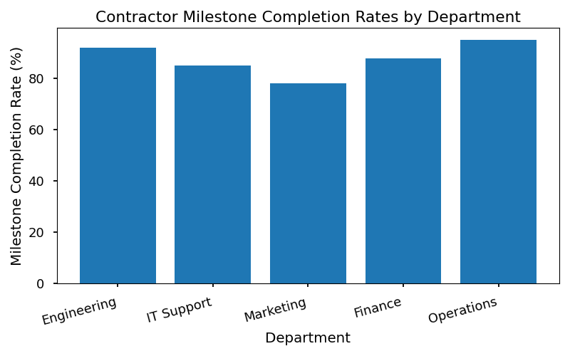

# Contractor Engagement Overview

Vmobile is committed to maintaining a productive, secure, and compliant workforce through the strategic engagement of contractors. This policy manual outlines the procedures, requirements, and standards for contractor engagement across all departments. All Vmobile employees and managers must adhere to these guidelines to ensure consistent practices and alignment with Vmobile’s operational objectives.

Contractors play a critical role in supporting Vmobile’s business needs, particularly in areas requiring specialized skills or short-term project support. Contractor engagement is governed by Vmobile’s HR and IT policies, which ensure that contractors are onboarded, managed, and offboarded in accordance with company standards.

## Contractor Type Comparison

The following table provides an overview of the primary contractor types engaged by Vmobile, their typical engagement durations, and their designated reporting managers. All managers listed are responsible for overseeing contractor performance, compliance with Vmobile policies, and coordination of work assignments.

|  |  |  |
| --- | --- | --- |
| **Contractor Type** | **Engagement Duration** | **Reporting Manager** |
| Field Technician | 6–12 months | Network Operations Lead |
| IT Support Specialist | 3–9 months | IT Manager |
| Customer Care Trainer | 1–6 months | Training Supervisor |
| Network Optimization Analyst | 6–12 months | Engineering Manager |

### Engagement Procedures

* **Field Technicians** are engaged for infrastructure deployment, maintenance, and troubleshooting across Vmobile’s network sites. Engagements typically last 6–12 months and are managed by the Network Operations Lead.
* **IT Support Specialists** provide technical support for internal systems and are contracted for 3–9 months, reporting to the IT Manager.
* **Customer Care Trainers** deliver training programs for customer service teams, with engagements of 1–6 months under the supervision of the Training Supervisor.
* **Network Optimization Analysts** analyze and optimize network performance, engaged for 6–12 months and reporting to the Engineering Manager.

### Contractor Management Responsibilities

* Managers are responsible for conducting regular performance reviews, verifying timesheets, and ensuring contractors have access only to necessary Vmobile systems.
* Contractors must comply with Vmobile’s Code of Conduct, data protection standards, and all relevant HR and IT policies.
* All contractors are required to complete mandatory onboarding and security awareness training prior to commencing work.

## Contractor Distribution by Department

Vmobile actively monitors and manages the distribution of contractors across departments to align with strategic priorities and operational demands. The following chart illustrates the current percentage distribution of contractors by department, based on internal workforce planning data.

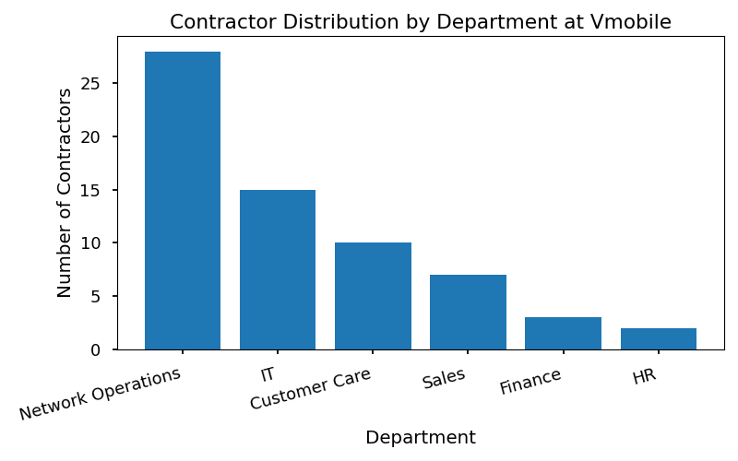

* **Network Operations:** 40%
* **IT:** 25%
* **Customer Care:** 20%
* **Engineering:** 15%

### Departmental Engagement Guidelines

* **Network Operations** utilizes the highest proportion of contractors for field deployment and technical support.
* **IT** engages contractors primarily for system upgrades, helpdesk support, and project-based assignments.
* **Customer Care** contracts trainers to deliver onboarding and skill development for frontline staff.
* **Engineering** engages analysts for network optimization and technical project support.